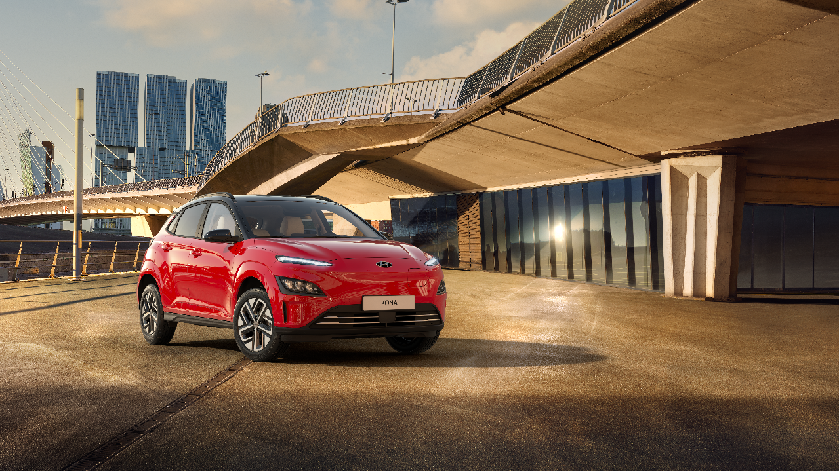

KONA ELECTRIC



**ANNUAL TCD Fee SENIORS Fee**

$1,184.04 $562.10

**RUST PROOFING**

**$**695.00

**ANNUAL RUST PROOFING INSPECTION**

$245.00

**WARRANTY**

5 Years / 100,000km

**\*PRICING SUBJECT TO CHANGE PER SHIPMENT**

Monotone $46,995* Two-tone $47,595*

**Sunroof option:** Monotone only $47,995*

**Class F**

Interior Trim: Black Leather

**OPTIONS**

Electric Tilting & Sliding Sunroof (Mono-tone exterior colour only)

2-Tone Body Color

**AVAILABLE COLOURS**

|  |  |  |  |  |  |  |  |  |  |  |  |  |  |  |  |  |  |  |  |  |  |  |
| --- | --- | --- | --- | --- | --- | --- | --- | --- | --- | --- | --- | --- | --- | --- | --- | --- | --- | --- | --- | --- | --- | --- |
| |  | | --- | | **MONOTONE** | | **Phantom Black** | | **Atlas White** | | **Cyber Gray** | | **Dark Knight Gray** | | **Pulse Red** | | **Surfy Blue** | | **Dive Blue** | | **Jungle Green** | | **Galactic Gray** | | **Ignite Red** | | |  | | --- | | **TWO-TONE WITH BLACK ROOF** | | **Atlas White** | | **Cyber Gray** | | **Dark Knight Gray** | | **Pulse Red** | | **Surfy Blue** | | **Dive Blue** | | **Jungle Green** | | **Galactic Gray** | | **Ignite Red** | |

**\*\*VEHICLES SUPPLIED INCLUDES BERMUDA SPECIFICATIONS**

**SPECIFICATIONS**

|  |  |  |  |
| --- | --- | --- | --- |
| |  |  | | --- | --- | | * Model Year 2022 * 64.0 kwh Lithium-Ion Polymer Battery * On Board Charge (Maximum capacity: 7.2kw) * Charge Time: (7.2KWH OBC):10∼100%, approx. 9 hrs 15 mins * Quick Charge (10∼80%) 50 Kw - approx. 64 mins; 100 kW – approx. 47 mins * All Electric Range: 484 km / 300.74 miles * 17” Alloy Wheels * LED Headlights + Rear LED Combi Headlights * Smart Key + Push Button Start * Electric Folding Mirrors * Automatic Air Conditioning * Power Front Seats + Driver Lumbar Support * Heated Seats (Front & Rear) + Ventilated Front Seats * Airbags: Front, Thorax & Pelvis +Curtain * LED Overhead Console Lamp W/ Sunglass Case * LED 2nd Row Room Lamp * LED Front Foot Lamp + Led Luggage Lamp | * Regenerative Brakes * Electric Parking Brake * Power Windows * Rear View Monitor * Parking Distance Warning; Forward/Reverse * Steering Wheel Remote Control * Bluetooth w/Voice Recognition * 8" Display + Radio + Harman/Kardon Premium Speakers * Apple CarPlay / Android Auto * Electronic Chromic Mirror + Rear View Mirror * Heads-Up Display * Blind-Spot Collision Warning * Rain Sensor * Wireless Charger (Phone) * USB Charger-Console (1port) * Mud Guards * Inner Condenser HVAC | |  |